HURTWOOD HOUSE

Policy on Visitors to the School

Reviewed | By | Last reviewed | Last modified
Annually | SMT  CE | May 2025 | May 2024

Policy on Visitors to the School

Aims
Hurtwood House recognises that visitors need to come onto its premises on a regular basis. Whilst this must be possible so the life of a busy school can be conducted Hurtwood House recognises the need to protect those within our community and our visitors.

Where and to whom the policy applies
The school is deemed to have control and responsibility for its pupils anywhere on the school site (i.e. within the school boundary), during normal school hours, during extra-curricular activities and on school organised (and supervised) off-site activities. The policy applies to:
- All staff employed by the school
- All external visitors entering the school site during the school day or for extra-curricular activities (including peripatetic tutors, sports coaches, and topic related visitors e.g. authors, journalists)
- All parents and volunteers
- All students
- Other education related personnel (advisors, inspectors)
- Building & maintenance and all other independent contractors visiting the school premises
- Independent contractors who may transport students on minibuses or in taxis

Procedures
All visitors to the school may be asked to bring formal identification with them at the time of their visit. They must follow the procedure below.

- All visitors must report to the reception area located inside the front doors of the main School building, or departmental office where they will be working (maintenance, theatre, media, dance, music or careers)

- Signs on the front and side door as well as at the entrance to the car park will direct visitors to the reception area

- If being invited onto school premises the School will endeavour to make visitors aware of this requirement in advance of their visit

- On entry, all visitors must state the purpose of their visit and who has invited them. They should be ready to produce formal identification upon request

- Visitors will be required to sign a visitor’s book indicating the time of arrival, indicating the likely length of their stay, who they are visiting and their car registration.

- Visitors may be asked to wear a badge for the duration of their visit – this badge must be visible throughout their visit

- Visitors will then be escorted to their point of contact OR their point of contact will be asked to come to receive the visitor. The contact will then be responsible for them while they are on site. The visitor must not be allowed to move about the site unaccompanied unless the appropriate vetting checks have been undertaken or they appear on the Approved Visitor List.

- At the end of their stay they must sign the visitor’s book to indicate their actual departure time and return their visitor badge, if appropriate.

- Visitors to all boarding Houses must inform the member of staff on duty of their presence, and sign the Boarding House Visitors Book, recording the time of arrival and departure. Notices to this effect are displayed at all entrances to boarding areas. No visitors should be at boarding houses before 8:30 am without the prior permission of the duty staff.

- All visitors will be supervised appropriately at all times

Approved Visitor List
The School will hold an Approved Visitor List for visitors who frequently visit the school site to undertake work within the school (including contractors).

To qualify for inclusion on this list the visitor must have demonstrated, prior to the visit that:
- They have a current clear enhanced DBS check AND
- A Children’s Barred List check has been undertaken AND
- Visitors on the Approved List MUST follow the same procedures on entry to the premises. A copy of the approved visitor list will be kept behind reception at all times.

The School will check the identity of Approved Visitors on arrival on the first day of work at the School. Individuals will be expected to provide photo ID in the form of a passport or drivers licence. For the avoidance of doubt, no one will be able to commence work at the school until this evidence has been provided.

Who is a visitor?
A visitor may be defined as someone who has business in the School beyond mere delivery of materials and other requisites such as food. It may include service contractors, workmen, visiting speakers and parents – indeed anyone who may have unaccompanied access to the School site.

Enforcement
Everyone in the School community should see this policy as enabling them to feel safer and more comfortable in their surroundings and thus it should be acceptable to enquire of any visitor seen without a badge if they can be assisted and, if necessary, accompanied to the central reception area.

Unknown/Uninvited Visitors to the School
Any visitor to the school site who is not wearing an identity badge should be challenged politely to enquire who they are and their business on the school site. They should then be escorted to reception to sign the visitors book. The procedures above will then apply.

In the event that the visitor refuses to comply, they should be asked to leave the site immediately and a member of the Senior Management Team (SMT) informed. The SMT member will consider the situation and decide if it is necessary to inform the police.

If an unknown/uninvited visitor becomes abusive or aggressive, they will be asked to leave the site immediately and warned that if they fail to leave the school grounds, police assistance will be called for.

Staff Development
As part of their induction, new staff will be made conversant with this policy and asked to ensure compliance with its procedures at all times.

Protocols for outside speakers
Occasionally, we have speakers from our wider community who enrich our student's experience of school, providing students with information that helps them make decisions at different phases of their education, widening their understanding of world and global issues and providing motivational inspiration through the sharing of a speaker's experience. Our responsibility to our students is to ensure that they can critically assess the information they receive as to its value to themselves, and that the information is aligned to the ethos and values of the school and British values of democracy, the rule of law, individual liberty and mutual respect and tolerance of those with different faiths and beliefs.

We achieve this through the following protocols:
- The organiser must ascertain that all information communicated by the visitor/speaker:
  - is consistent with the core values and ethos of the school;
  - supports fundamental British values;
  - does not marginalise any community, group or individuals;
  - does not seek to glorify criminal activity or violent extremism or seek to radicalise others.
- All requests for outside speakers must be discussed with the Deputy Head (Curriculum) (DHC) and the form (appended to this policy) must be completed and returned to the DHC.
- The DHC will request a biography of the speaker or institution with the purpose clearly defined as to the information the speaker/visitor wishes to communicate.
- When sufficient information has been collated the DHC will be able to make a decision giving permission for the visitor/ speaker to come to School. For the visitor/speaker to be approved, the criteria above must be met.

Further guidelines
School safeguarding procedures apply and visiting speakers should normally have photograph identity from their institution. They will be issued with a visitors' badge which they must wear at all times. Visitors are accompanied in the buildings at all times.

Monitoring during the presentation
Staff will be present during the visit and they will ensure that the content of the presentation, resources and opinions/beliefs are consistent with the aforementioned conditions. In the unlikely event that the presentation does not meet this requirement, Visitors will be informed that school staff have the right and responsibility interrupt and/or stop a presentation and immediate action will be taken by the member of staff to balance the information given. The member of staff will report this to the DHC as soon as reasonably practicable after the presentation/visit.

Visiting Speakers will be supervised by a member of school staff whilst on School site. At no point will a Visiting Speaker be left unsupervised on School site whist students are present.

Post speech/ visit evaluation
The speech/ visit is evaluated by the organiser as to whether it met the needs of our students. Should the visit/speaker not meet the needs of our students then this will be clearly communicated to the visiting speaker/ institution by the DHC.

Linked policies
This policy and procedures should be read in conjunction with other related school policies, including:
- Child Protection & Safeguarding Policy
- Health and Safety
- Fire Safety (Prevention) Policy
- Recruitment, Selection and Disclosure Policy and Procedure

Authorised by | resolution of the Partners  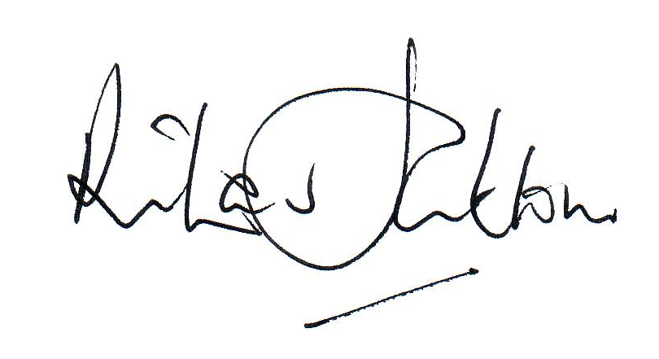  
Date | 24/06/2025

Effective date of the policy | 1st September 2025
Circulation | All staff / Parents / Students [on request]

HURTWOOD HOUSE

Application for Approval of Visiting Speaker

This form should be submitted for approval by the Deputy Head – Curriculum before any booking is made preferably with no less than one month’s notice.

Name of Speaker:
Organisation:
Purpose of visit:

Date & Time:
Details of Visit:
(Including how it fits into the curriculum)
Cost:
(Fees and expenses)

Please ensure a biography of the speaker is attached to this form

Organiser’s Declaration
I have read and understood the Visitors to School Policy. I agree to:
- Ensure the information the speaker wishes to communicate aligns to the school’s core values and ethos and to fundamental British Values
- Ensure that all information communicated by the speaker is lawful, does not marginalise any community, group or individuals and does not seek to glorify criminal activity or violent extremism or seek to radicalise others
- Supervise the speaker for the duration of their visit
- Be present during the visit and monitor the speech to ensure it aligns with the school’s core values and ethos and to British values
- Take immediate action to balance the information given in the unlikely event the speech does not meet requirements
Signed |  | Date
Deputy Head - Curriculum Approval
I have read the above application and I am satisfied that all aspects have been considered.
Approval is given to proceed with arrangements for this visit as outlined above.
Signed |  | Date

